StyleBook

Software Development Plan

Version <1.0>

Revision History

| **Date** | **Version** | **Description** | **Author** |
| --- | --- | --- | --- |
| <dd/mmm/yy> | <x.x> | <details> | <name> |
|  |  |  |  |
|  |  |  |  |
|  |  |  |  |

Table of Contents

**1.** **Introduction 4**

**2.**  **Project Overview 4**

*2.1* *Project Purpose, Scope, and Objectives 4*

*2.2* *Assumptions and Constraints 4*

*2.3* *Project Deliverables 4*

**3.**  **Project Organization 4**

*3.1* *Organizational Structure 4*

*3.2* *Roles and Responsibilities 4*

**4.**  **Management Process 4**

*4.1* *Project Estimates 4*

*4.2* *Project Plan 4*

4.2.1 Phase and Iteration Plan 5

4.2.2 Releases 5

4.2.3 Project Schedule 5

4.2.4 Project Resourcing 5

*4.3* *Project Monitoring and Control 5*

4.3.1 Reporting 5

4.3.2 Risk Management 5

4.3.3 Configuration Management 6

Software Development Plan

# 

# Introduction

This document provides the overall plan of developing an application that provides clothing shop management with virtual try-on for the customers, it also acts as a social media for people to share their fine sense of fashion.

# Project Overview

## Project Purpose, Scope, and Objectives

* Purpose: To connect people via fashion social media.
* Scope: The project will include research, development.
* Objectives:

## Assumptions and Constraints

* There will be four people in the group, no extra people will be joining the team.
* Zero budget.
* The project will be limited to 10 weeks.

## Project Deliverables

* Data Model
* Design Model
* Database Design
* Testing
* Test Summary

# Project Organization

## Organizational Structure

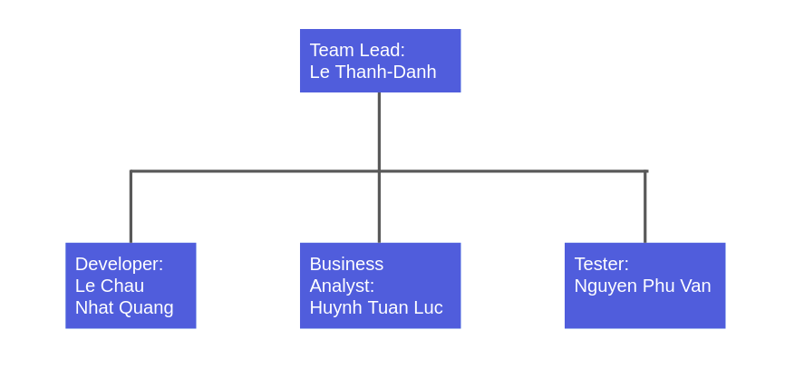

## Roles and Responsibilities

| Person | Roles |
| --- | --- |
| Le Thanh-Danh | Project Management(Team Lead), DevOps, ML Engineer, MLOps |
| Le Chau Nhat Quang | Architect(Developer), Frontend Developer, Designer |
| Huynh Tuan Luc | Business Analyst,  Data Analytics |
| Nguyen Phu Van | Tester, Backend Developer |

# Management Process

## Project Estimates

*[Provide the estimated cost and schedule for the project, as well as the basis for those estimates, and the points and circumstances in the project when re-estimation will occur.]*

## Project Plan

This section contains the schedule and resources for the project.

### Phase and Iteration Plan

| Phase | Start | End |
| --- | --- | --- |
| Inception | Week 1 | Week 3 |
| Elaboration | Week 3 | Week 5 |
| Elaboration | Week 5 | Week 7 |
| Construction | Week 7 | Week 10 |

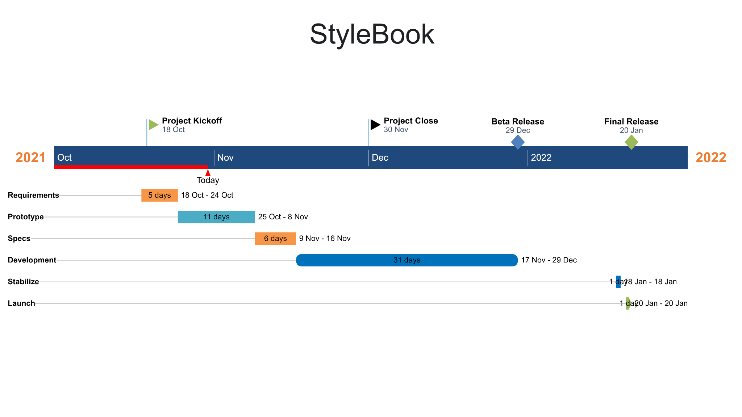

### Releases

After releasing the application. We will have a fashion social media. Users can communicate with others throughout the platform. They can quickly contact the shop owners. The application will recommend for users with clothes suitable as most could be fashionable.

### Project Schedule

*[Diagrams or tables showing target dates for completion of iterations and phases, release points, demos, and other milestones.*

*MS project schedule can be copied here]*

## Project Monitoring and Control

### Reporting

* The team meets 2 times a week. The first meeting is at 20h-21h Monday. The second one is meeting at 20h-21h Thursday.
* [Weekly status report](https://docs.google.com/document/d/13IIM0-Eprjj0dW6GRKb-gkEaWhbFKhB2/edit?usp=sharing&ouid=105715286984325378988&rtpof=true&sd=true)

### Risk Management

| Risk ID | Risk Description | Probability | Impact | Priority | Mitigation Strategy or Contingency Plan |
| --- | --- | --- | --- | --- | --- |
| 1 | Dependencies conflicted: in React Native, we sometimes need to install additional libraries (a.k.a. dependencies). And there are cases where these libraries conflicted on other team member devices but not on the one who installed it. | Very low | The application and other member who involved to the application source code | High | This needs to be fixed immediately since the application cannot be compiled or it will crash while running when dependencies are conflicted. The easiest solution is to reinstall the library. If reinstalling it does not fix it then we can delete all dependencies and install them again. The final solution is to replace it with a different library or implement our own library from scratch. |
| 2 | Some components are not consistent on Android OS and iOS. This happens when we use libraries from open source that did not completely support both OS or the version of both OS. | Low | The application and end user | Moderate | Since Android devices are diverse with different brands and versions so to assure the application is consistent on every device is an impossible task. In order to reduce the probability of this risk, we need to consider the libraries carefully. If this happens while developing, replace it with a different library or implement our own library from scratch. |
|  |  |  |  |  |  |

### Configuration Management

* Google drive for storing and sharing documents and files*.*
* Git/Github for managing source code and related files.
* Slack for communication between team members
* Trello board for handling tasks.